(Approx. 1891 words)

DOS Lives!
By Dick Maybach, Member, Brookdale Computer Users’ Group, NJ
BUG Bytes
www.bcug.com
n2nd (at) att.net

Are you nostalgic for the days of DOS? Do you miss making disastrous typos on the command line or trying to find an AUTOEXEC.BAT that will let your PC complete the boot process? There is good news, for you can return to those thrilling days of yesteryear on your present computer with its GigaBytes of RAM, TerraBytes of disk, and obscenely high-definition display, regardless of what operating system you use. You can work with GWBasic or Turbo C and play those old text games, such as Adventure, or those with what passed for graphics, such as Leisure Suit Larry. An easy means of doing this is by using the free program DOSBox, http://www.dosbox.com/, which is available for Windows, OS X, and Linux.
DOSBox can run DOS programs that require the CPU to be in either real or protected mode, independent of its host CPU and operating system. It can emulate many types of display and sound hardware, such as text, CGA, EGA, or VGA for display and the PC speaker, AdLib, or Sound Blaster for sound. Storage is handled by mapping a drive letter in the emulator to a directory, image file, diskette drive, or CDROM drive on the host computer. DOSBox can simulate peer-to-peer or Internet/Intranet networking and is capable of timing-compatible implementation of the serial ports, which can enable older hardware and software dependent on serial port timing to work. Printing can be problematic; you'll probably use screen-shots for graphics and transfer text files to your host for it to print.
DOSBox provides a high-level emulation of the DOS and BIOS interrupts, and contains its own internal DOS-like shell. This means that it can be used without owning a license to any real DOS operating system. However, using copy-protected diskettes or those with non-standard formats is generally not possible.
When you install DOSBox, it creates a configuration file, which doubles as both CONFIG.SYS and AUTOEXEC.BAT. Its name and location vary with operating system; access it in Windows with the sequence ﻿﻿Start > All Programs > DOSBox-0.74 > Options; in Linux it’s located at ~/.dosbox/dosbox-0.74.conf, and in OS X at ~/Library/Preferences/DOSBox 0.74 Preferences. Regardless of your OS, you’ll need to create a directory that DOSBox will use as a virtual C: hard drive. When first installed it sees only a Z: drive, which is reserved for its internal use. The first time you boot your prompt will be “Z:>:” showing that you are on the Z: drive. To mount the directory you've designated as your C: drive issue the following commands.
mount C <full pathname of directory>
C:
You probably want to put these commands in your configuration file so you won't have to retype them every time you start DOSBox. At the end of this file are the following lines. (Those beginning with # are comments.)
[autoexec]
# Lines in this section will be run at startup.
# You can put your MOUNT lines here.
I've defined two disks on my Linux system, and this section now has seven additional lines to emulate a C: and an A: disk, to modify the search path, and to move to the C: drive.
[autoexec]
# Lines in this section will be run at startup.
# You can put your MOUNT lines here.
# Mount C: on /home/n2nd/.dosbox/C_Drive
mount C /home/n2nd/.dosbox/C_Drive
# Mount A: on /home/n2nd/.dosbox/A_Drive
mount A /home/n2nd/.dosbox/A_Drive
# Add Turbo Pascal to path
PATH=Z:\;C:\BIN;C:\TP
C:
On a Windows system, lines 4 and 5 above might be the following.
# Mount C: on C:\C_Drive
mount C C:\C_Drive

Above this section, the configuration file performs the same functions as CONFIG.SYS. The only change I made here was to enlarge the DOSBox window, which by default is 640 by 480 pixels, quite small on modern displays. I changed two lines.
windowresolution=original
output=surface
into
windowresolution=1024x768
output=overlay
The first enlarges the window and the second is optional. It speeds up the display and allows scaling, but may not be compatible with all systems. Screen 1 shows the DOSBox boot screen after making these changes.

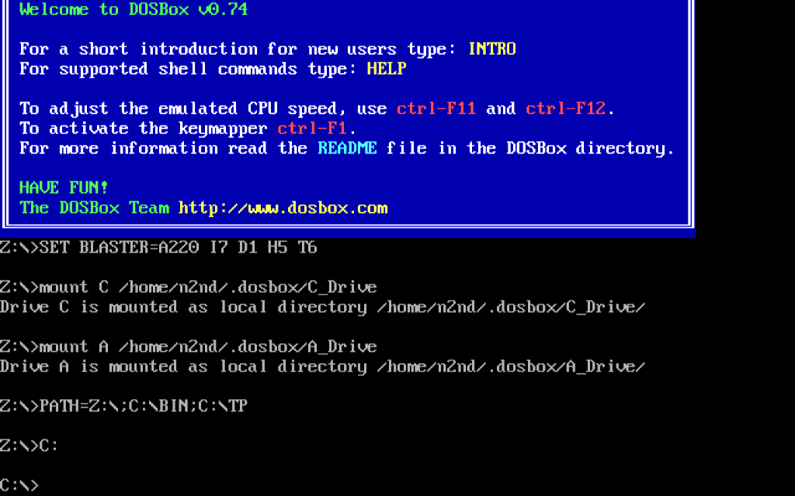
Screen 1. DOSBox Boot Screen.

As you can see from the blue welcome message, some help is available (for more detailed information, see the tutorial on the DOSBox Website). The first output line shows the emulated sound card parameters (which you can change) followed by the commands in the AUTOEXEC.BAT portion of the configuration file and their effects.

The uncommented lines from bottom portion of the configuration file are visible within DOSBox as Z:\AUTOEXEC.BAT as Screen 2 shows. However, they can be changed only by editing the configuration file from your computer’s operating system. This screen also shows a portion of the help output.

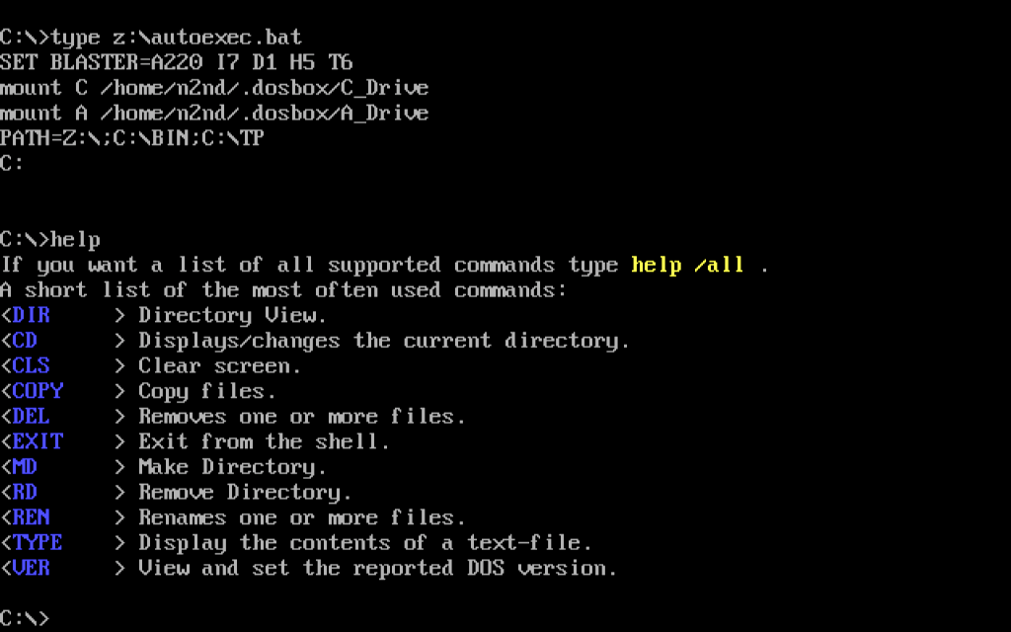
Screen 2. Autoexec.bat and Help.

The INTRO command produces several screens of information, the last of which is shown in Screen 3. These commands were not available in the original DOS, but using them can be essential here. For example, some DOS programs were available on several diskettes, and you were required to swap them during the installation. I was able to install such programs by placing the contents of the first diskette on the directory mapped to the DOSBox A: drive and starting the installation. When told to change diskette, I went to my PC's operating system, deleted the contents of this directory and wrote the contents of the second diskette there. Then in DOSBox I typed <CTL><F4> and continued installing. You will also often use <CTL><F10> to capture or release the mouse and <CTL><F9> to close DOSBox.

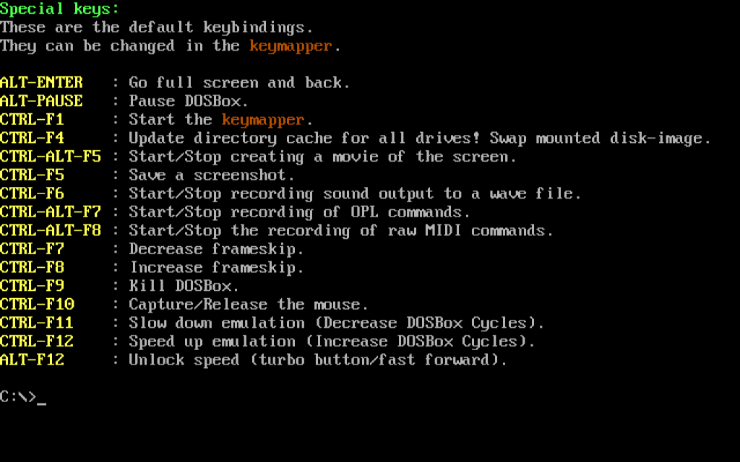
Screen 3. Special Keys.

Screen 4 shows the software bundled with DOSBox, although there are more commands internal to COMMAND.COM. As you can see, it includes only the basic utilites, but useful (as well as frivolous) DOS software is widely available (for example at Abandonia (http://www.abandonia.com/en) and the Internet Archive (http://archive.org/). A little searching will unearth much more, some free and legal, some at small cost, and a lot of course pirated. You may also have old DOS diskettes, which you can use, provided they aren't copy-protected and you still have a working diskette drive. I had saved a package of Infocom games and was able to download legal copies of Adventure, Leisure Suit Larry, GWBasic, QBasic, Turbo C, and Turbo Pascal. Much of the early DOS software was available only as Basic code, and the system is incomplete without an interpreter to run it. Almost as important, the original manuals for the languages are also available. While it’s possible to learn a game by trial and error, this is far from true for a language compiler or interpreter.

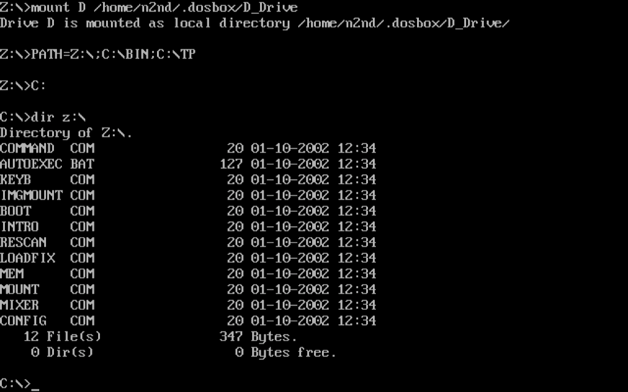
Screen 4. DOSBox External Programs.
Keeping a DOS filesystem organized takes some effort. Both the programs and files reside in the same area, although experienced DOS users learned to keep them in separate directories. A key quantity was PATH, which specified where the PC should look for executable files. When first installed, the DOSBox path is set to Z:\ which is the directory that holds all the system software. As you can see from Screen 1, I expanded this only slightly by adding C:\TP (required by Turbo Pascal) and C:\BIN (the directory that holds my added software).

As I mentioned above, you will probably want to add GWBasic to be able to run early DOS programs, but more advanced languages were also available, such as QBasic (which Microsoft began using with MS-DOS 5), Pascal, and C. (By the way, GWBasic and QBasic programs are incompatible. You may need both to do serious DOS archeology.) Borland's successor, Embarcadero, http://cc.embarcadero.com/Default.aspx, now makes both Turbo Pascal and Turbo C available for free. Screen 5 shows Turbo C with a snippet of code.
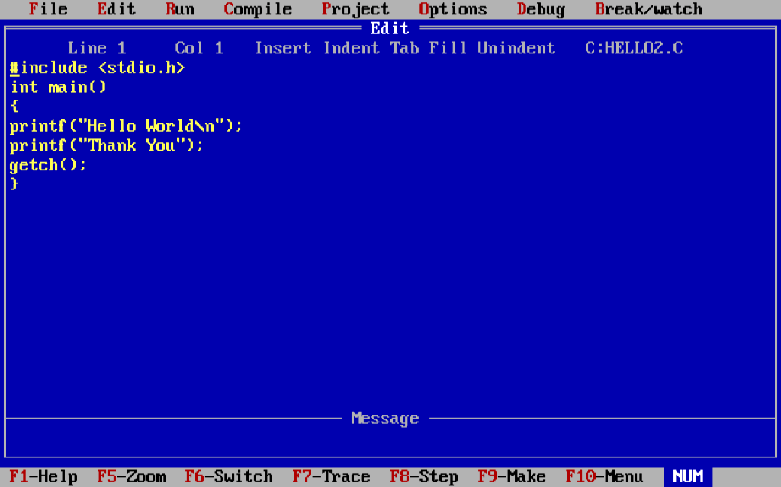
Screen 5. Turbo C.
The program is a complete development environment; you can edit, compile, run, and debug your code without ever leaving it. (Turbo Pascal uses the same environment, and those for QBasic and GWBasic are quite similar.) If you’re familiar with C, you probably noticed the last statement, which doesn’t appear in most hello-world programs. It’s needed because when a program ends, you jump back to the development environment. Here getch() causes the program to wait for you to type a character, which means the screen displays the program output until you do that. Without it, you would have to exit the environment to run the program and see what is does.

Many DOS games are text only, and one of the first I played was Adventure; Screen 6 shows this in progress. You’ll need a cheat sheet to get very far, but these are also readily available.

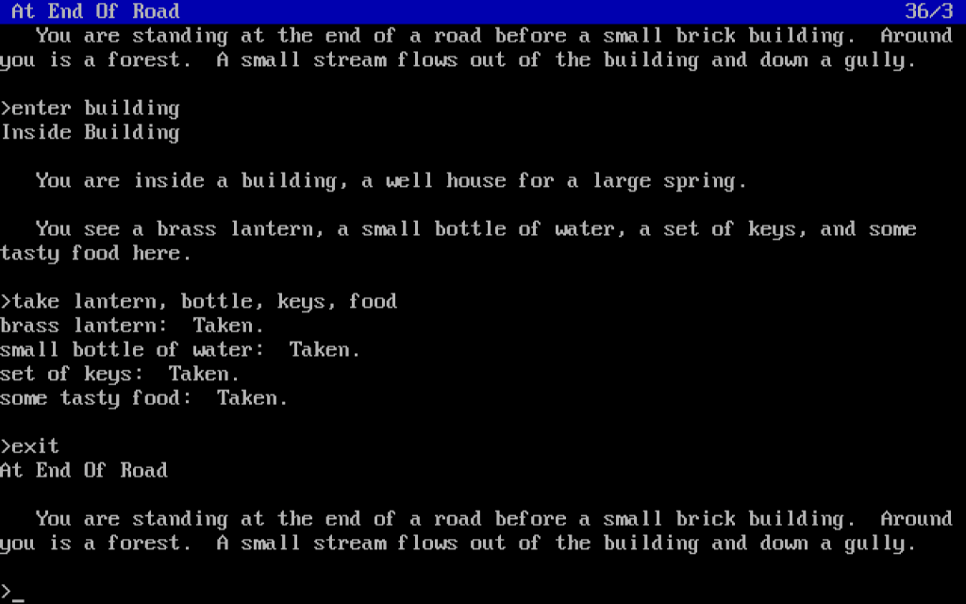
Screen 6. Adventure.

There are many games with crude DOS graphics and tin-whistle music, such as the mildly racy Leisure Suit Larry, shown in Screen 7.

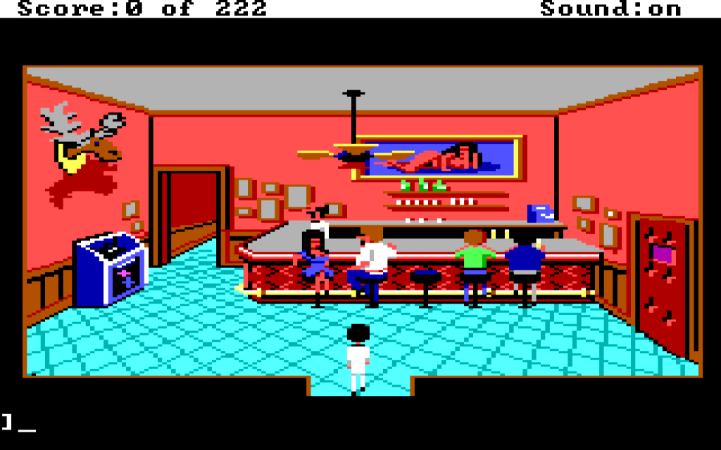
Screen 7. Leisure Suit Larry.

DOXBox is not the only way to return to DOS; there is also the far more complete open-source FreeDOS, http://www.freedos.org/download/, which you can install as a dual-boot alternative to your normal operating system. Although it may be more convenient to install it as a virtual machine, for example using VirtualBox, https://www.virtualbox.org/. Step-by-step instructions for doing this are available at http://wiki.freedos.org/wiki/index.php/VirtualBox. (These are for earlier versions of both programs, but the differences are minor. Just don't expect to see exactly the same screens.) Using this approach allows you to run DOS programs at the same time as your other computing tasks.

FreeDOS is probably overkill for most people, but if you may need it to do serious work in DOS; Screen 8 shows its opening screen.

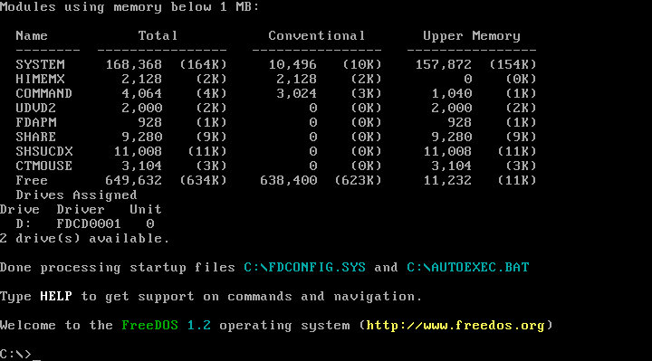
Screen 8. FreeDOS.

Screen 9 shows the commonly-used external DOS commands (those not internal to COMMAND.COM) that are included with the standard installation. As you can see, there are far more than what DOSBox provides.

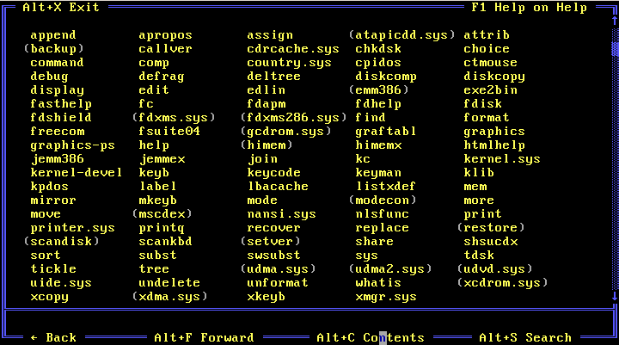
Screen 9. FreeDOS Commands.

If you decide to try FreeDOS, be aware that the download includes many applications that aren't installed by default, but reside in the ISO image as ZIP files, which is available as disk D:. Install them with FDIMPLES, as shown in Screen 10.

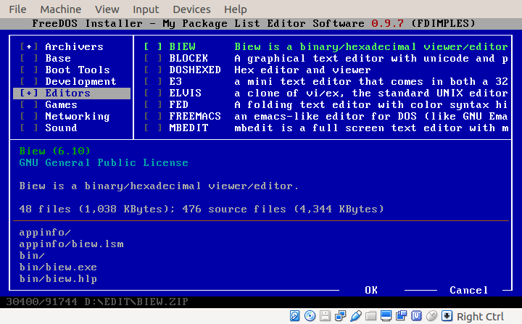
Screen 10. Using FDIMPLES to install additional programs.

However, running it on VirtualBox entails some limitations. You can't drag and drop items from the host OS to FreeDOS while its running, there is no shared disk, and USB devices aren't recognized. The most convenient way to transfer information to your host OS is to set up a virtual network connection, and if FreeDOS is not running, you can transfer files to its virtual disk. (See the manual referenced above.) You can also write to a mounted CD-ROM or ISO file.

As I said, most users will find that DOSBox is entirely satisfactory and more convenient to use than FreeDOS. Both provide a safe way to experiment with DOS. DOSBox can access only the files in the directories you mount as drives. (For this reason, please don’t follow the advice in some articles that you should mount your entire C: disk.) FreeDOS can see only the partition on which it’s installed (if you dual boot) or on the virtual drive (if you use a virtual machine). Despite these safeguards, prudent users will scan anything they download for malware before they try to use it.

Taking a nostalgic trip back to the 1980s with either of these will surely increase your appreciation of your current computing environment.

